VAJE 3

AVTOR: LUKA SITAR

1. Naloga

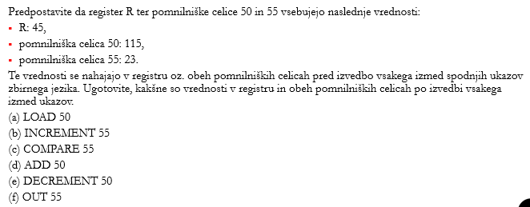

1. R = 115, M(50) = 115, M(55) = 23
2. R = 45, M(50) = 115, M(55) = 24
3. R = 45, M(50) = 115; LT = 1, M(55) = 23
4. R = 160, M(50) = 115, M(55) = 23
5. R = 45, M(50) = 114, M(55) = 23
6. R = 45, M(50) = 115, M(55) = 23; izpiše se vrednost 23
7. Naloga

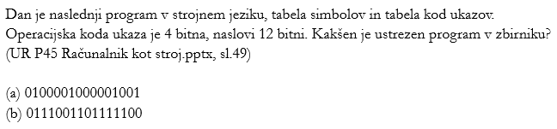

1. 0100001000001001

Koda ukaza: 0100

Naslov: 001000001001

* INCREMENT 29 + 23 + 20
* INCREMENT 521

1. 0111001101111100

Koda ukaza: 0111

Naslov: 001101111100

* COMPARE 210 + 29 + 27 + 26 + 25 + 24 + 23
* COMPARE 1784

1. Naloga

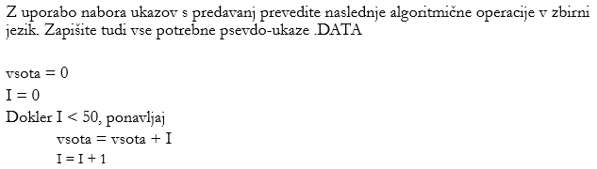

LOAD FIFTY

DO:

COMPARE I

JUMPEQ DONE

ADD I VSOTA

ADD ONE I

JUMP DO

DONE:

END

FIFTY: .DATA 50

I .DATA 0

VSOTA .DATA 0

ONE .DATA 1